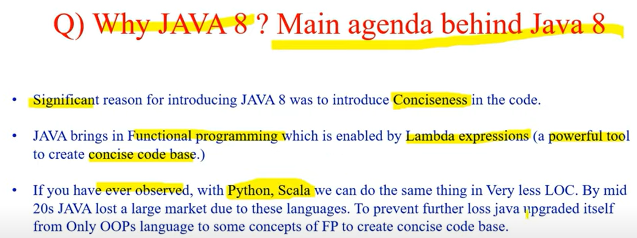

Features of Java 8

Lambda Expression

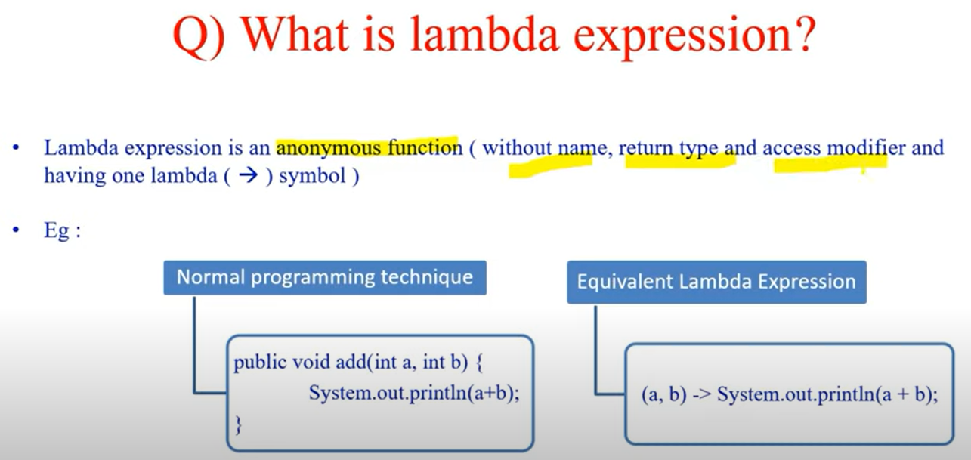

BiConsumer 🡪 is nothing but a predefined functional interface. Available in java.util.function package.

BiConsumer will accept 2 values and returns nothing.



Functional Interfaces

Functional Interface is used to provide reference to lambda expressions.

To call lambda expressions we need Functional Interfaces.

**Method Reference**

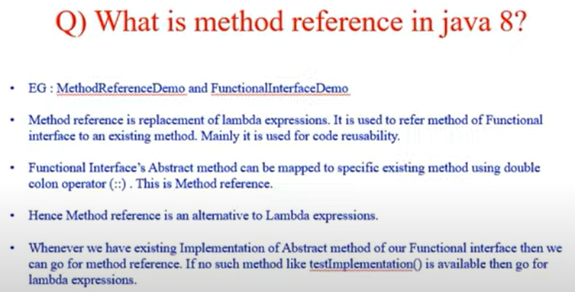

Default Methods

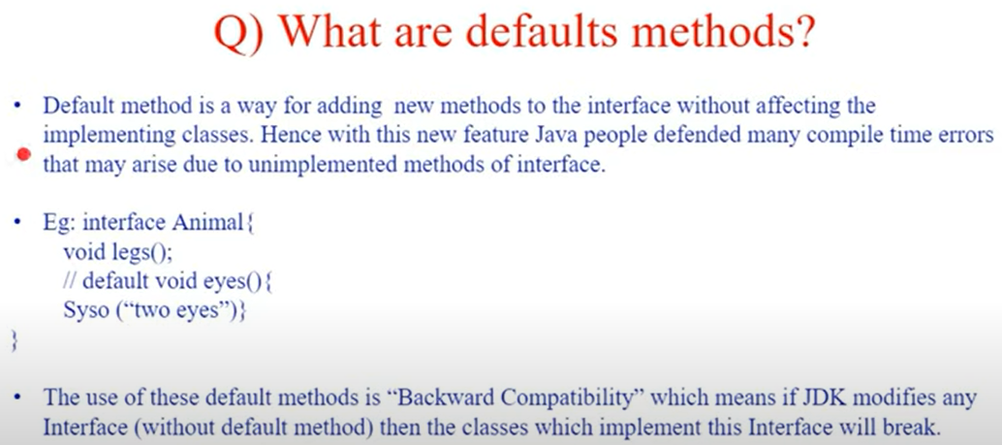

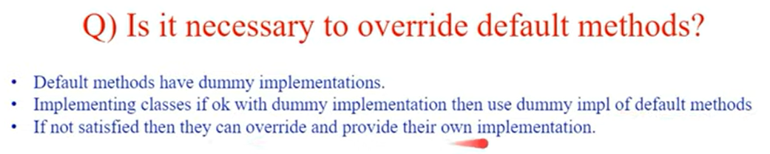

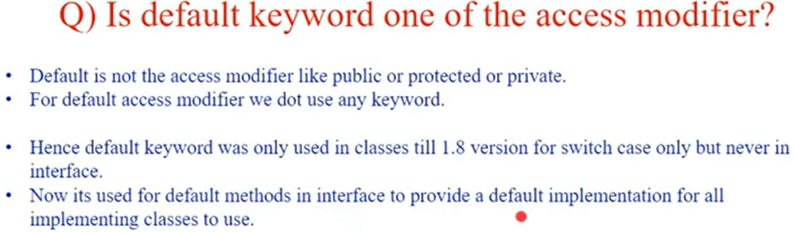

Static Methods in Interface – Java 8

Static methods will only be visible to interface not to the inherited classes. So to use we have to call by interface name. static method name.

Predicate 🡪 Return type is always Boolean – accepts one parameter and checks the condition.

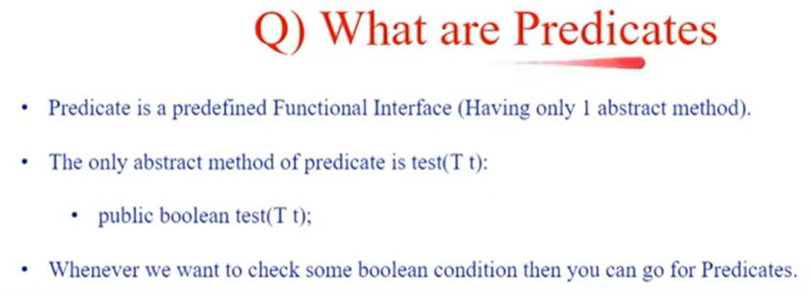

Negate 🡪 will reverse the result of Boolean Test. It will always accept one Test as input while for And & Or we will require minimum of 2 Test or input.

***Functions 🡪 it is used for performing operations on 1 input parameter & result to be processed (result might not in Boolean)***

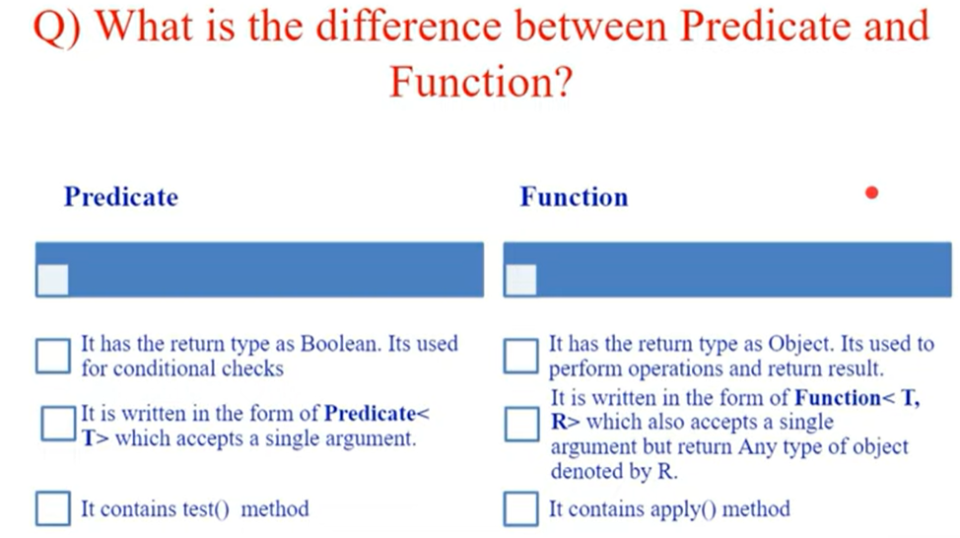

Predicate 🡪 test () method & Function 🡪 apply() method can be used reuse the code.

***Functions 🡪 Chaining***

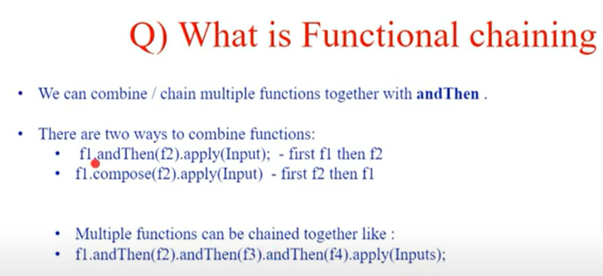

Consumer Functional Interface

Consumer Chaining

Supplier

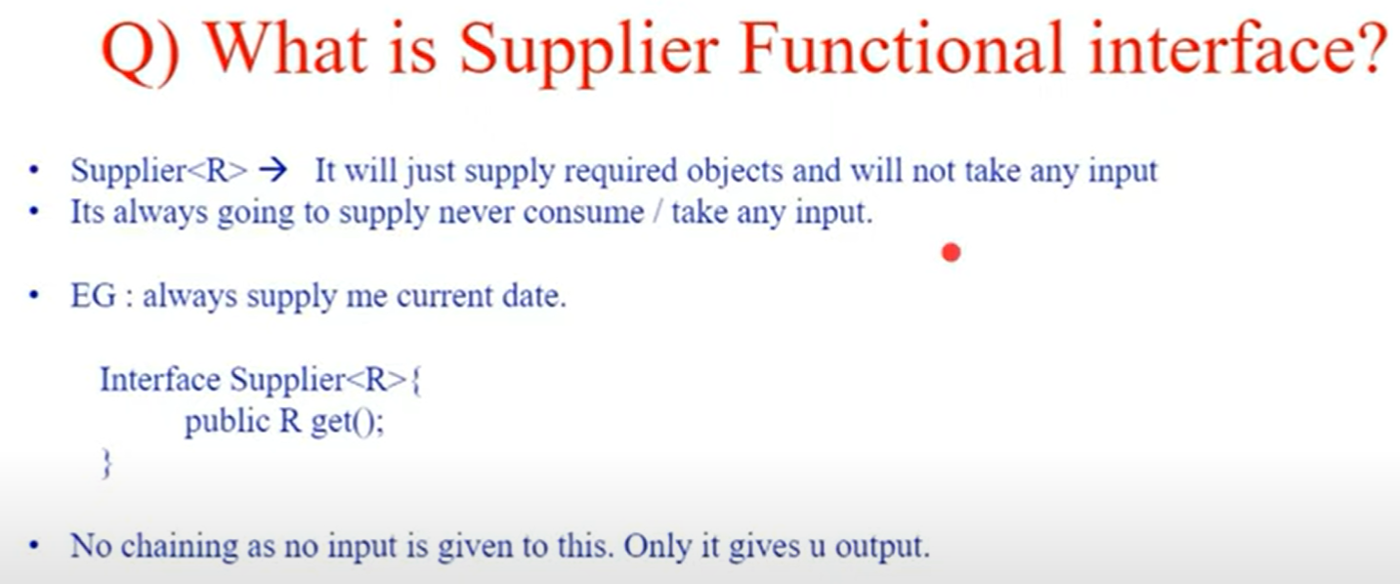

Use of BiConsumer BiFunction BiPredicate and BISupplier

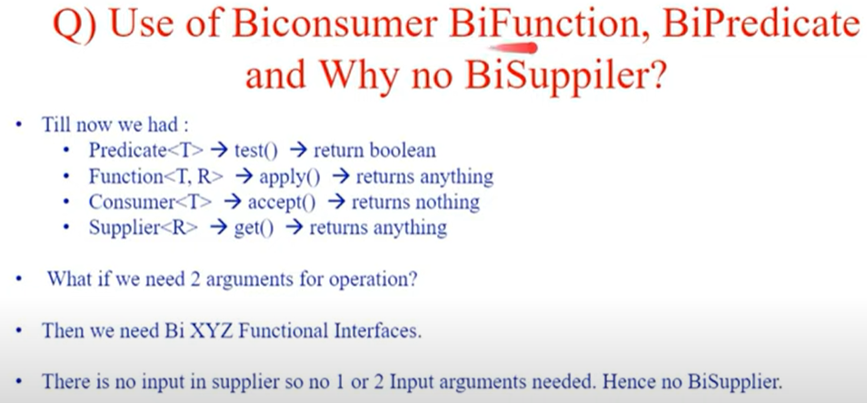

***Streams***

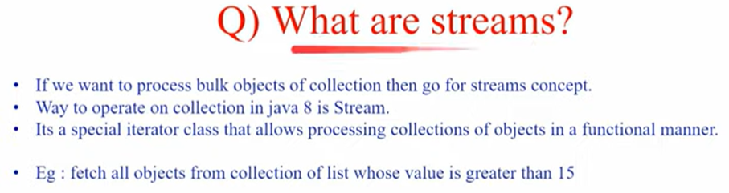

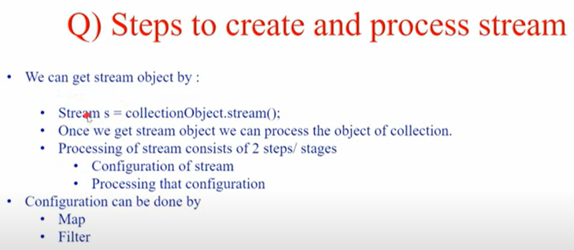

**Configuration of Stream**

**Processing of Stream**

Static Methods

**Static methods can only be used with interface name not with the implemented classes.**